Div 2 League
Date | Opposition | Comp. | Venue | Result
03/03/2019 | Oughterard | Div 2 | Oughterard | Draw 1-12 to 2-9
18/03/2019 | Kilconly | Div 2 | Knockdoe | Draw 2-9 to 1-11
31/03/2019 | Cortoon | Div 2 | Brownesgrove | Won 0-14 to 2-9
14/04/2019 | St James | Div 2 | Knockdoe | Won 1-12 to 8pts
27/04/2019 | Moycullen | Div 2 | Moycullen | Lost 0-18 to 2-11
12/05/2019 | Oranmore | Div 2 | Lakeview | Won 1-17 to 2-13
08/06/2019 | Aran Islands | Div 2 | Inis Mor | Lost 0-17 to 1-12
27/07/2019 | Carraroe | Div 2 | Knockdoe | Draw 2-17 to 4-11
04/08/2019 | Barna | Div 2 | Furbo | Lost 0-16 to 0-15

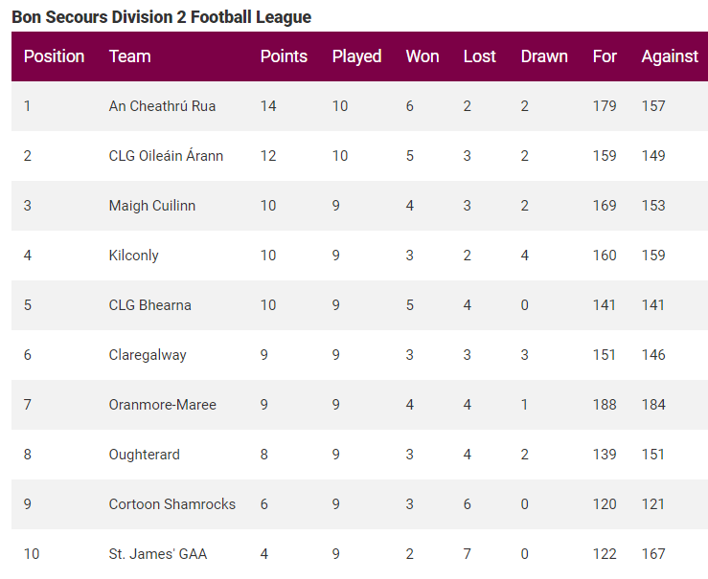

Senior Championship
Date | Opposition | Comp. | Venue | Result
25/05/2019 | Annaghdown | Senior Champ | Athenry | Won 3-11 to 0-12
23/06/2019 | Naomh Anna | Senior Champ | Pearse Stadium | Won 3-16 to 0-6
18/08/2019 | St James | Senior Champ | Pearse Stadium | Won 1-14 to-1-13
25/08/2019 | Corofin | Senior Champ | Tuam Stadium | Lost 2-18 to 2-11
08/09/2019 | Tuam | Senior Champ | Kenny Park | Lost 1-13 to 0-8
22/09/2019 | Salthill QF | Senior Champ | Tuam Stadium | Lost 0-13 to 1-9
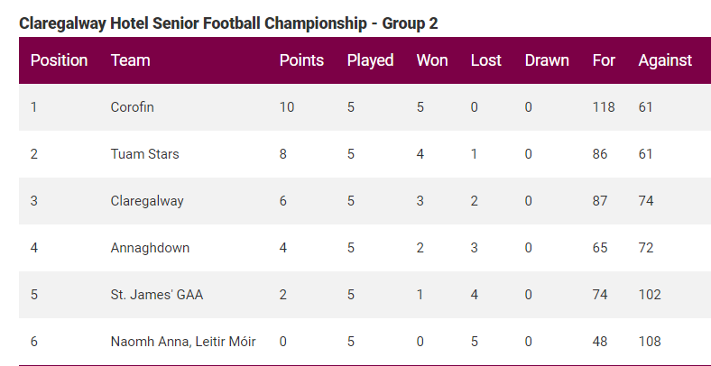

Div 5 League
Date | Opposition | Comp. | Venue | Result
30/03/2019 | Carraroe | Div 5 | Lakeview | Draw 1-11 each
13/04/2019 | St James | Div 5 | Mervue | Won 4-11 to 1-7
28/04/2019 | Na Piarsaigh | Div 5 | Lakeview | Draw 2-12 each
10/05/2019 | Killannin | Div 5 | Killannin | Lost 0-16 to 1-9
07/06/2019 | Salthill | Div 5 | Salthill | Lost 5-17 to 1-10
14/06/2019 | Moycullen | Div 5 | Lakeview | Lost 0-16 to 3-11
12/07/2019 | Barna | Div 5 | Lakeview | Won 1-12 to 1-10

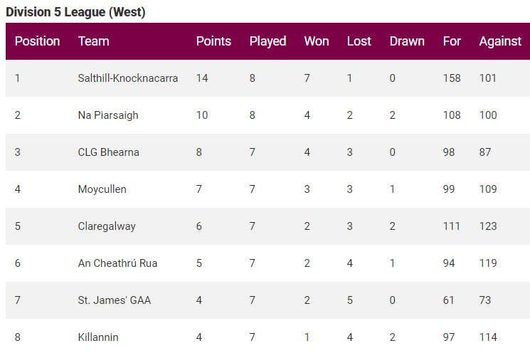

Junior Championship
Date | Opposition | Comp. | Venue | Result
21/06/2019 | St Michaels | Junior Champ | Westside | Won 2-14 to 1-10
10/08/2019 | Renville | Junior Champ | Claregalway | Won 1-14 to 1-13
22/08/2019 | Fr Griffin / Eire Og | Junior Champ | Claregalway | Lost 2-9 to 3-7
07/09/2019 | Salthill QF | Junior Champ | Prairie | Lost

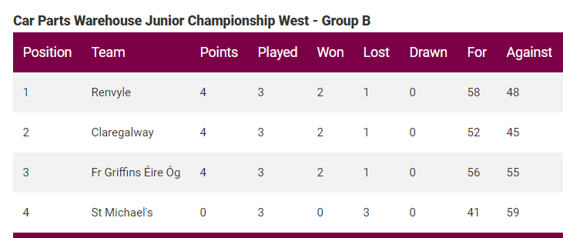

Junior B League
Date | Opposition | Comp. | Venue | Result
28/04/2019 | Milltown | Div 8 | Lakeview | Won 2-18 to 2-13
22/05/2019 | Annaghdown | Div 8 | Cregg | Won 1-15 to 1-14
14/06/2019 | Corofin | Div 8 | Corofin | Won 5-12 to 0-8
14/07/2019 | Glenamaddy | Div 8 | Lakeview | CONC
21/07/2019 | Corofin Final | Div 8 | Tuam Stadium | Won 0-11 to 0-5

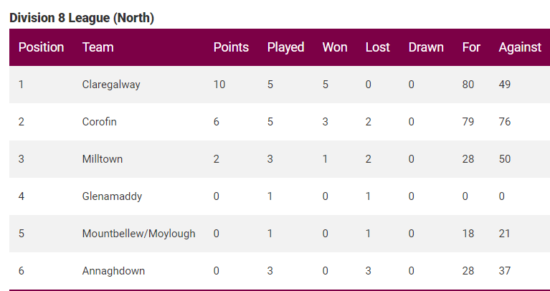

Junior B Championship
Date | Opposition | Comp. | Venue | Result
09/08/2019 | Williamstown | Jnr B Champ | Williamstown | Won 0-13 to 0-11
23/08/2019 | Caltra | Jnr B Champ | Lakeview | Won 1-11 to 1-05
06/09/2019 | Dunmore | Jnr B Champ | Dunmore | Draw 2-12 each
22/09/2019 | Headford NB Semi | Jnr B Champ | Lakeview | Lost 2-11 to 2-10

John Dunne Cup
Date | Opposition | Comp. | Venue | Result
17/02/2019 | Caherlistrane | John Dunne | Knockdoe | Won 2-13 to 2-5
22/03/2019 | Headford | John Dunne | Headford | Lost 0-19 to 1-5

U20 Championship
Date | Opposition | Comp. | Venue | Result
28/10/2019 | Monivea / Abbey | U20 | Monivea | Won 4-17 to 2-01
16/11/2019 | Annaghdown | U20 | Creggs | Won 2-11 to 0-8
30/11/2019 | Corofin North Final | U20 | Tuam Stadium | Won 3-16 to 2-13
15/12/2019 | Salthill Co. Final | U20 | Ballinasloe | Won 0-9 to 0-8
19/10/2019 | Caherlistrane | U20B | Caherlistrane | Lost 1-12 to 0-9

Minor League
Date | Opposition | Comp. | Venue | Result
24/03/2019 | Caltra | Minor League | Caltra | Lost 5-12 to 1-5
03/04/2019 | Caherlistrane | Minor League | Lakeview | Lost 1-7 to 0-6
10/04/2019 | St Gabriels | Minor League | Kilconnell | Lost 1-15 to 2-11
17/04/2019 | Northern Gaels | Minor League | Lakeview | Lost 2-16 to 1-09
24/04/2019 | Corofin | Minor League | Corofin | CONC

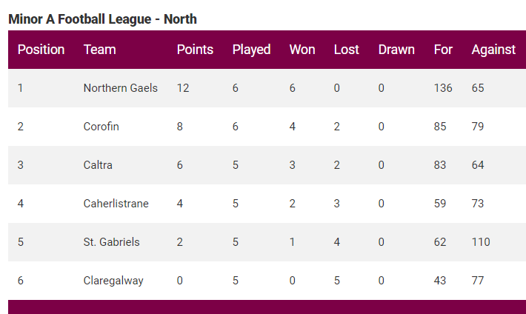

Minor Championship

Date | Opposition | Comp. | Venue | Result
11/07/2019 | Caltra | Championship | Caltra | Lost
05/09/2019 | St Gabriels | Championship | Knockdoe | Won
13/09/2019 | Northern Gaels | Championship | Glenamaddy | Won
06/10/2019 | Caltra (NB Final) | Championship | Tuam | Lost

